Edu-Bot

Proposal

Design
Keep design simple, geometric and robotic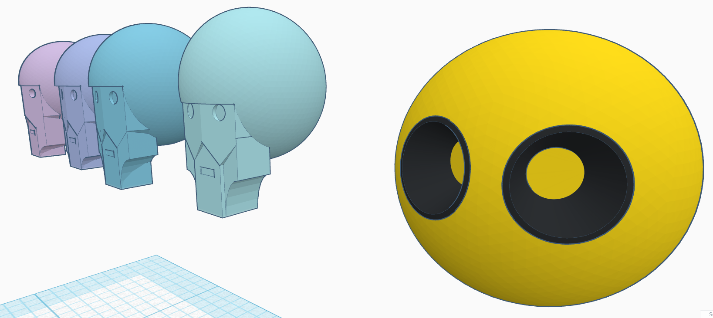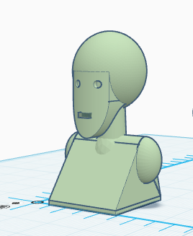
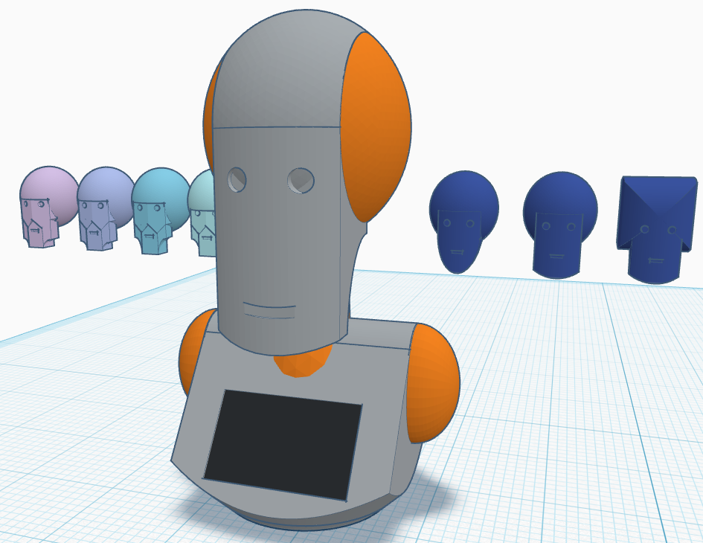

Development

Given the short time span to develop the body (September), we should start with a simple bust. Initially restrict animation to eyes and mouth and if possible Pitch and Yaw (Nod for yes and shake for no). The chest of the bust can hold the screen.
In future, another degree of freedom for head, (roll for inquisitive) arms can be added and then a mobile base or legs.

Animation elements:

Item | Description | No | Cost £
Circular Eye Display | 32.5mm LCD TFT Display LINK | 2 | 10
Mouth LED Matrix | 8x8 LED Matrix Display 32 x 32 mm LINK | 1 | 3.5
Dynamixel Servo | AX-18A LINK | 2 | 204
Dynamixel controller | PC starter set LINK | 1 | 66
TOTAL |  |  | £283.5

AI and Robot structure:

Item | Description | No | Cost £
Jetson Nano Orin | SBC and peripherals, power supply, SSD storage, Camera, Mic, Speaker and HDMI lead. LINK | 1 | 379
Computer Tablet |  | 1
PLA filament | 1 Kg | 1 | 22
TOTAL |  |  | £401

Expressions

Type | Description
ACTIVE | Actions coordinated with LLM output
Thinking | Eyes look up-left head move left-up
Nodding | Head moves up-down
Shaking | Head moves left-right
Talking | Head makes subtle movements, LED array displays sine waves
PASSIVE | Involuntary Actions when idle
Blinking | Intermittent blinking - short period
Long Blink | Longer blink,- longer period
Look Around | Head turns and eyes move, left and right - long period

Requirements

The software should provide ROS2 string messages to indicate which expressions are required, This is to be the only way to ensure that the expressions synchronise with the LLM output.
The LLM should be tested on a similar platform (e.g. Jetson Nano Orin) before being provided for testing.

